**Cape Verde country profile**

Published

5 December 2018

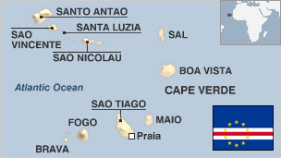

**Poor in natural resources, prone to drought and with little arable land, the Cape Verde islands have won a reputation for achieving political and economic stability.**

The former Portuguese colony comprises 10 islands and five islets, all but three of which are mountainous. The archipelago lies around 500 km off the west coast of Africa.

It was at one time an important centre of the slave trade.

During the 20th century severe droughts caused the deaths of 200,000 people and prompted heavy emigration. Today, more people with origins in Cape Verde live outside the country than inside it. The money that they send home brings in much-needed foreign currency.

* See [picture gallery](http://www.bbc.co.uk/news/world-asia-35101008)
* Read more [country profiles](http://news.bbc.co.uk/1/hi/country_profiles/) - Profiles by [BBC Monitoring](http://bbc.co.uk/monitoring)

**President: Jorge Carlos Fonseca**

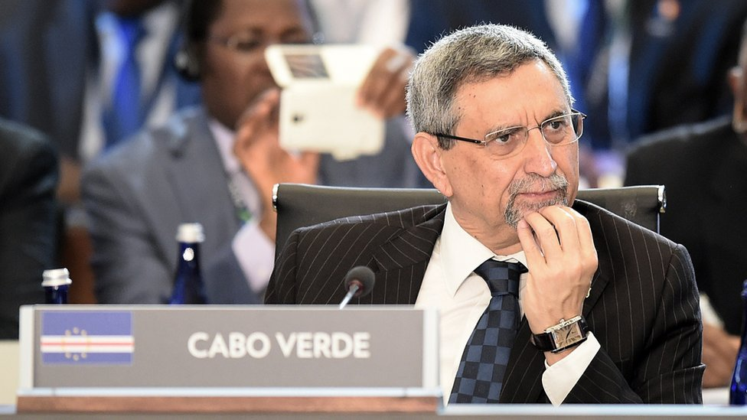image copyrightGetty Images

Jorge Carlos Almeida Fonseca was elected president in August 2011 and re-elected with 79% of the vote in October 2016.

Cape Verde is a republic with a president, who is the head of state, and a prime minister who heads the government. The prime minister is appointed by parliament.

**Prime minister: Ulisses Correia e Silva**

Ulisses Correia e Silva was sworn in as prime minister in April 2016 after leading his Movement for Democracy (MPD) to victory in a general election.

His party ousted the ruling African Party for the Independence of Cape Verde (PAICV) for the first time in 15 years.

He was mayor of the capital Praia between 2008 and January 2016. He has a background in banking, and has served as secretary of state and minister for finance.

The PAICV and the MPD have dominated politics since independence from Portugal in 1975. Both have run the country since multi-party democracy was introduced in 1991.

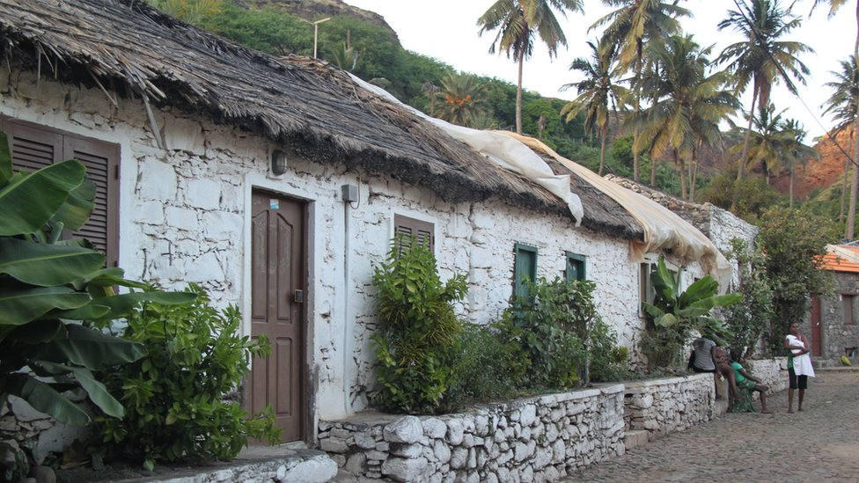image copyrightBojan Kveder

Cape Verde was ranked second highest among African countries listed in the Reporters Without Borders world press freedom index in 2014.

Much of the media is state-run, but there is an active private press and a growing number of private broadcasters.

There were 200,000 internet users by 2014 (Internetlivestats.com).

# Cape Verde profile - Timeline

Published

8 May 2018

## A chronology of key events

**1456** - First Europeans arrive in Cape Verde.

**1495** - Cape Verde becomes a Portuguese crown colony.

**1956** - Amilcar Cabral, a native of Cape Verde, co-founds the African Party for Independence of Guinea and Cape Verde (PAIGC) in Guinea-Bissau.

**1960** - PAIGC-led liberation war begins against Portuguese rule in Guinea-Bissau, with many Cape Verdeans joining in.

## Independence

**1975** - Cape Verde becomes independent and adopts constitution envisaging unity with Guinea-Bissau.

**1980** - Cape Verde ditches plans for unity with Guinea-Bissau following coup in latter.

**1981** - African Party for the Independence of Cape Verde (PAICV) replaces the PAIGC and becomes the country's sole party.

**1991** - Antonio Mascarenhas Monteiro becomes president following Cape Verde's first free election.

**1992** - A new constitution brings in a multi-party system.

**1996** - Mascarenhas Monteiro is re-elected and his party, the Movement for Democracy, wins a majority of seats in parliamentary elections.

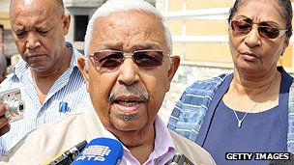image copyrightGetty Images

image captionPedro Pires became president in 2001

**2001** January - Government accepts defeat in parliamentary elections, paving the way for the return to power of the former ruling African Party for the Independence of Cape Verde, the PAICV.

**2001** March - Pedro Pires, from the Party for the Independence of Cape Verde, is elected president after beating his rival, the Movement for Democracy's Carlos Veiga, by 17 votes.

**2006** January-February - Governing PAICV wins parliamentary elections and incumbent leader, Pedro Pires, is victorious in closely-contested presidential polls.

**2006** June - Some 7,000 Nato troops take part in war games on Sao Vicente island. This is the organisation's first major deployment in Africa.

## WTO membership

**2007** December - World Trade Organization (WTO) council approves Cape Verde's accession to the organisation.

**2009** August - US Secretary of State Hillary Clinton ends seven-nation tour of Africa in Cape Verde.

**2009** November - National emergency declared following outbreak of dengue fever.

**2010** July - A Syrian prisoner who had been detained at Guantanamo Bay by the US is transferred to Cape Verde.

**2010** October - UN office on drugs and crime, UNODC, launches a project for cooperation between Brazil and seven West African countries - including Cape Verde - to tackle drug trafficking.

**2010** February - Governing PAICV party wins parliamentary elections.

**2011** August - Jorge Carlos Fonseca becomes president.

**2011** December - Two days of national mourning are declared on death of singer Cesaria Evora, considered to be one of the greatest exponents of Morna, a form of blues regarded as Cape Verde's national music.

**2014** November/December - Biggest eruption in decades of Cape Verdean volcano Pico do Fogo destroys two villages, forcing 1,500 people to flee their homes.

**2016** March - Movement for Democracy (MPD) wins parliamentary elections, leader Ulisses Correia e Silva becomes prime minister the following month.